## UNIVERSITY COLLEGE OF ENGINEERING ARNI

**(A Constituent College of Anna University Chennai) THATCHUR , ARNI - 632301**



## A PROJECT REPORT

HASTAG GENERATION

(ELECTRONICS AND COMMUNICATION ENGINEERING)

Faculty Mentor(s) Name

Mr. VENKATNARAYANAN .,M.E.,

By

**Deepika K**

Nithyarupini G

Jaipriya S

Swetha S

ANNA UNIVERSITY : CHENNAI 600 025



## BONAFIDE CERTIFICATE

Certified that this project report “**HASTAG GENERATION”** is the bonafide work carried out the project work under my supervision.

## SIGNATURE SIGNATURE

Mrs.R.Ezhilarasi.,M.E.,(Ph.D.) Mr.Venkatnarayanan,M.E., HEAD OF THE DEPARTMENT SUPERVISOR

Department of ECE Department of ECE

University College of University College of

Engineering-Arni Engineering -Arni

Submitted for the project viva voce held on 03-11-2023

**INTERNAL EXAMINER EXTERNAL EXAMINER**

# ACKNOWLEDGEMENT

At the outset we express our deep gratitude to the almighty Lord for bestowing his grace and blessing upon us to complete the project. We convey our special gratitude and thank to our honourable Dean **Dr.G.SENTHIL KUMAR,M.Sc.,M.phil.,Ph.D.,** for providing us with necessary facilities for the completion of our project and helping us with his valuable inputs.

We truly thank our project coordinator **Dr.R.EZHILARASI,M.E.,Ph.D.,** Head of the department of Electronics and Communication Engineering for her advice, innovation, support and encouragement for the completion of this project.

We sincerely thank our internal guide **Mr.C.Venkatnarayanan,M.E.,** faculty of the Department of Electronics and Communication Engineering for his valuable guidance, ideas, inspiration and encouragement for the successful completion of this project.

We extend our sincere thanks to all the faculty members of department of Electronics and Communication Engineering for their valuable suggestions. We are also thankful to those who helped us directly and indirectly in the completion of our project work.

# ABSTRACT

In the digital age of social media and online content creation, hashtags have emerged as powerful tools for enhancing content discoverability, user engagement, and message amplification. However, the art of crafting the right hashtags that resonate with one's audience and align with the content's purpose can be a challenging endeavor. To address this challenge, the Hashtag Generation project introduces a sophisticated solution designed to automatically generate relevant and engaging hashtags for various forms of online content.

This innovative tool leverages advanced natural language processing (NLP) and artificial intelligence (AI) algorithms to perform deep content analysis, extracting keywords, understanding context, and ensuring that the generated hashtags are contextually appropriate. It incorporates real-time trend awareness, seamlessly integrating trending hashtags to keep users at the forefront of popular discussions.

The Hashtag Generation project emphasizes user customization, allowing individuals and businesses to fine-tune the suggested hashtags, add their own, or remove those that do not align with their unique preferences and brand identity. It also supports multiple languages and regional variations, enabling users to connect with their audiences in their preferred language and location.

Privacy and accessibility are paramount in this solution, ensuring that user-provided content is not stored or shared and that the tool is accessible to a diverse user base, including those with disabilities.

With a commitment to delivering relevant, diverse, and engaging hashtags, this project aims to enhance content visibility, user engagement, and the overall impact of online communication. By automating the hashtag generation process, it offers users a powerful and efficient way to optimize their online presence while saving valuable time and effort.

The Hashtag Generation project represents a valuable tool for individuals, businesses, and content creators seeking to harness the full potential of hashtags in the digital landscape, and it holds the promise of making online content more accessible, engaging, and impactful.

Top of Form

## INTRODUCTION

* 1. Project Overview
  2. Purpose

## PROJECT DEFINITION & DESIGN THINKING

## 2.1 Empathy Map

## Paste the Empathy map screenshot

## 2.2 Ideation & Brainstorming Map

## Paste the ideation and brainstorming map screenshot

## RESULT

## Final findings (output) of the project along with screenshots .

## ADVANTAGES AND DISADVANTAGES

## List of advantages and disadvantages of the proposed solution

## APPLICATIONS

## The areas where this solution can be applied

## CONCLUSION

## Conclusion summarizing the entire work and findings

## INTRODUCTION

**Project Overview:**

Providing a brief overview of the project named hastag generation, describing its purpose, goals, and context.

## Purpose:

## The purpose of hastag generator is to assist users in creating relevant and effective hastags for the social media posts and online content.

## IDEATION & PROPOSED SOLUTION

**Problem Statement Definition:**

Define the problem or challenge that the project aims to address.

Clearly articulate the problem statement and its significance.

In the realm of digital communication and social media, hashtags play a pivotal role in content discovery, audience engagement, and the broader reach of online posts. For individuals, businesses, and content creators, the ability to generate appropriate and effective hashtags is paramount. The problem statement for a Hashtag Generator revolves around developing a tool or application that can automatically suggest relevant and engaging hashtags for a given piece of content, be it a social media post, blog article, or other online content.

**Empathy Map Canvas:** Present an empathy map canvas, which helps understand the target users, their needs, and pain points.

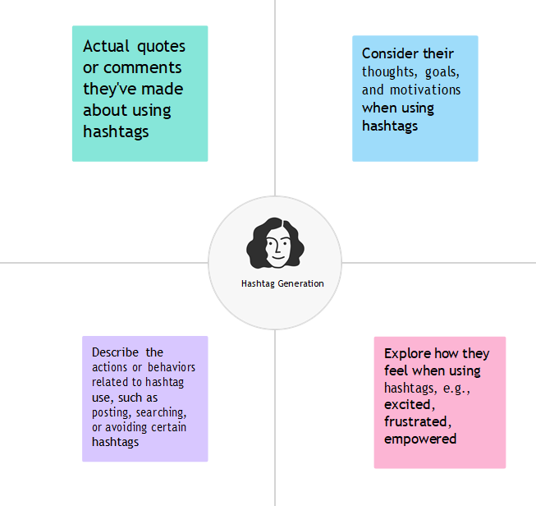

**Ideation & Brainstorming:** Describing the process of generating ideas and possible solutions to the identified problem. Explain how different ideas were considered and evaluated.

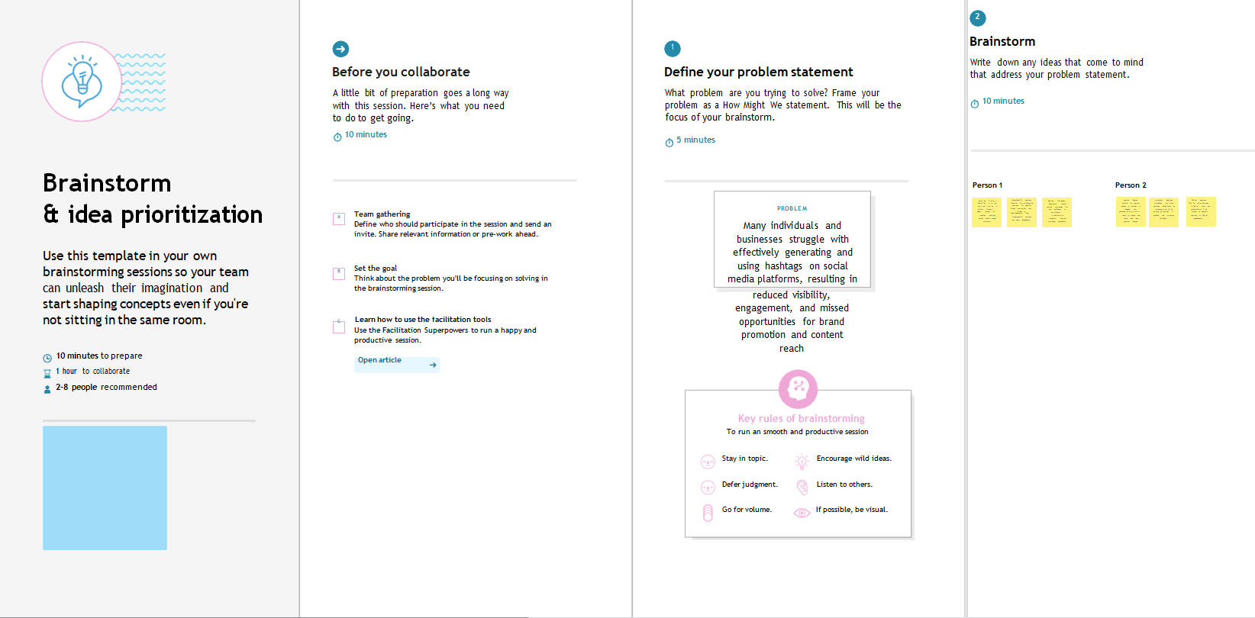

**PROJECT DESIGN PHASE-PART 1**

**PROPOSED SOLUTION FOR HASTAG GENERATION**

|  |  |  |
| --- | --- | --- |
| **S.no** | **Parameter** | **Description** |
|  | Problem Statement (Problem to be solved) | Problem Statement: Hashtag Generator  Introduction: Hashtags are a fundamental element of social media platforms, helping users discover content, connect with like-minded individuals, and increase the visibility of their posts. In this era of digital communication, the ability to generate relevant and engaging hashtags is crucial for individuals, businesses, and marketers looking to promote their content. The problem statement for a Hashtag Generator involves creating a tool or application that can automatically suggest appropriate hashtags for a given piece of content, whether it's a social media post, blog article, or any other form of online content.  Problem Description: The Hashtag Generator is designed to address the following key challenges:   1. Relevance: The generated hashtags should be relevant to the content, helping users reach their target audience and enhancing the discoverability of their posts. 2. Engagement: The suggested hashtags should encourage user engagement, leading to more likes, comments, and shares. 3. Diversity: The generator should produce a variety of hashtags, reducing the risk of repetition and overuse of the same hashtags. 4. Contextual Understanding: The tool should analyze the content and understand its context to generate suitable hashtags. It should consider the topic, tone, and purpose of the content. 5. User Input: Allow users to input a piece of text, image, or URL and generate relevant hashtags. 6. Customization: Offer the option for users to add, remove, or modify generated hashtags to suit their preferences. 7. Trend Awareness: Keep track of trending topics and generate hashtags related to current events or popular discussions. 8. Platform Compatibility: Ensure that the generated hashtags are suitable for the specific social media platform where the content will be shared (e.g., Instagram, Twitter, TikTok). 9. Language and Localization: Support different languages and consider regional variations and preferences for hashtag usage. 10. User Privacy: Safeguard user privacy by not storing or sharing the content provided by users. 11. Accessibility: Make the tool accessible to a wide range of users, including those with disabilities.   Deliverables: The Hashtag Generator should produce a list of relevant and engaging hashtags for a given piece of content. It can be implemented as a web application, mobile app, or integrated into existing social media platforms.  Evaluation: The success of the Hashtag Generator can be measured based on the following criteria:   1. Relevance: Evaluate how well the generated hashtags match the content's topic and purpose. 2. Engagement: Measure the increase in user engagement (likes, comments, shares) when using the generated hashtags compared to not using them. 3. User Satisfaction: Collect user feedback and ratings on the quality of generated hashtags and the tool's usability. 4. Diversity and Avoidance of Repetition: Assess the tool's ability to provide a variety of hashtags and avoid suggesting the same hashtags repeatedly. 5. Trend Relevance: Evaluate the tool's ability to suggest hashtags related to current trends and events.   Conclusion: A Hashtag Generator is a valuable tool for individuals and businesses looking to enhance their social media presence. It can save time and effort while improving the impact of online content. The successful implementation of a Hashtag Generator requires a deep understanding of natural language processing, content analysis, and social media trends. |
|  | Idea / Solution description | Solution Description: Hashtag Generator  Introduction: The Hashtag Generator is a tool designed to automatically suggest relevant and engaging hashtags for social media posts and online content. It aims to enhance the discoverability and visibility of user-generated content while saving time and effort. The following is a description of the solution for the Hashtag Generator:  Key Features:   1. Content Analysis:    * The generator will analyze the input content, whether it's text, an image, or a URL, to understand its topic, tone, and purpose. This analysis forms the basis for generating appropriate hashtags. 2. AI and Natural Language Processing:    * Leveraging advanced AI and NLP algorithms, the Hashtag Generator will extract keywords and phrases from the content to identify potential hashtags. 3. Relevance Assessment:    * The tool will assess the relevance of potential hashtags by comparing them to the content's analysis. Hashtags that align with the content's topic and purpose will be given preference. 4. Trend Integration:    * The Hashtag Generator will monitor current social media trends and incorporate relevant trending hashtags into the suggestions. This feature helps users ride the wave of popular discussions. 5. Customization:    * Users will have the option to modify the generated hashtags, add their own, or remove suggestions they find inappropriate. This customization ensures that the hashtags align with their unique preferences. 6. Platform Compatibility:    * The generator will consider the requirements of various social media platforms, such as character limits and best practices, and provide hashtags suitable for the chosen platform (e.g., Instagram, Twitter, TikTok). 7. Language and Localization:    * Support for multiple languages and an understanding of regional variations will allow users to generate hashtags that resonate with their target audience. 8. Accessibility:    * The tool will adhere to accessibility guidelines to ensure that it is usable by a broad range of individuals, including those with disabilities. 9. User Privacy:    * To respect user privacy, the Hashtag Generator will not store or share any user-provided content. All content analysis and hashtag generation will be performed in real-time and not retained.   Implementation:  The Hashtag Generator can be implemented as a web application, mobile app, or integrated directly into social media platforms. Here is a high-level overview of the implementation process:   1. Data Collection: The tool collects the user's input content, which can be in the form of text, images, or URLs. 2. Content Analysis: Utilizing AI and NLP techniques, the content is analyzed to extract keywords, phrases, and context. 3. Hashtag Generation: The generator suggests a list of relevant hashtags based on the analysis, taking into account the content's context and any trending topics. 4. Customization: Users can review and customize the suggested hashtags, adding or removing as needed. 5. Platform Integration: If integrated with a social media platform, the generated hashtags can be directly added to the user's post.   Evaluation:  The success of the Hashtag Generator can be evaluated through user feedback, engagement metrics (e.g., likes, comments, shares), and its ability to provide relevant and diverse hashtags.  Conclusion:  The Hashtag Generator is a valuable tool that enhances the effectiveness of social media content by providing users with relevant and engaging hashtags. Its AI-powered features, trend integration, and customization options make it a powerful solution for individuals and businesses seeking to optimize their online presence. |
|  | Novelty / Uniqueness | The uniqueness of a Hashtag Generator lies in its ability to provide tailored and relevant hashtags for social media posts and online content. Here are some key aspects that make a Hashtag Generator unique:   1. Content Analysis and Understanding: A Hashtag Generator employs advanced natural language processing (NLP) and AI algorithms to analyze the content and understand its context, topic, and purpose. This in-depth analysis ensures that the generated hashtags are directly related to the content, increasing their relevance. 2. Real-Time Trend Integration: The Hashtag Generator monitors current social media trends and seamlessly incorporates trending hashtags into the suggestions. This feature allows users to tap into popular discussions and gain more visibility. 3. Platform Compatibility: The generator takes into account the specific requirements of different social media platforms, such as character limits and best practices, and suggests hashtags suitable for the chosen platform. This adaptability enhances its usability across various platforms like Instagram, Twitter, TikTok, and more. 4. User Customization: Unlike generic hashtag suggestions, the Hashtag Generator provides users with the ability to customize the generated hashtags. Users can add, modify, or remove suggestions to match their unique preferences and brand identity. 5. Language and Localization: Many Hashtag Generators support multiple languages and understand regional variations, making it possible for users to connect with their target audience more effectively in their preferred language and location. 6. Privacy Concerns: The tool prioritizes user privacy by not storing or sharing any user-provided content. Content analysis and hashtag generation occur in real-time, protecting user data. 7. Accessibility: Hashtag Generators are designed with accessibility in mind, ensuring that the tool is usable by a wide range of individuals, including those with disabilities. This commitment to inclusivity sets it apart. 8. Enhanced Engagement: By providing users with hashtags that are both relevant and engaging, the Hashtag Generator contributes to increased user engagement, including likes, comments, and shares of their content. 9. Time and Effort Saving: The tool simplifies the process of generating effective hashtags, saving users time and effort that would otherwise be spent on manual hashtag research and creation. 10. Reduction of Repetition: Hashtag Generators aim to reduce the repetition of the same hashtags in multiple posts by offering a variety of relevant suggestions.   In summary, the uniqueness of a Hashtag Generator stems from its advanced content analysis, real-time trend awareness, platform compatibility, user customization, language support, privacy protection, accessibility, and its ability to enhance user engagement. These features collectively make it a valuable and distinct tool for social media users, marketers, and content creators. |
|  | Social Impact / Customer Satisfaction | Social Impact of Hashtag Generator:   1. **Enhanced Content Visibility:** Hashtag Generators help users, including individuals, businesses, and non-profit organizations, increase the visibility of their content on social media platforms. This can have a significant social impact by ensuring that important messages, awareness campaigns, and community-driven initiatives reach a wider audience. 2. **Amplifying Social Movements:** Hashtags are often used to support and promote social causes and movements. A Hashtag Generator can assist activists and advocates in creating impactful hashtags, thereby amplifying their messages and driving positive change. 3. **Promoting Inclusivity:** A well-designed Hashtag Generator can offer suggestions that are sensitive to diversity and inclusion, promoting respectful and inclusive conversations on social media. It can encourage users to embrace various perspectives and engage in constructive dialogues. 4. **Empowering Small Businesses:** Small businesses can benefit from the increased visibility provided by Hashtag Generators, allowing them to compete with larger enterprises on social media. This can lead to economic growth and job creation in local communities. 5. **Educational Impact:** Hashtag Generators can be used in educational settings to teach students about social media marketing, content optimization, and the power of effective communication. This can empower the next generation with valuable digital skills.   Customer Satisfaction for Hashtag Generator:   1. **Relevance and Effectiveness:** Users are more likely to be satisfied if the generated hashtags are relevant to their content and contribute to its success. The more effective the hashtags are in increasing engagement, the higher the satisfaction level. 2. **Ease of Use:** The user interface of the Hashtag Generator should be intuitive and user-friendly. Users should find it easy to input their content and understand how to utilize the generated hashtags. 3. **Customization:** Allowing users to customize the suggested hashtags is crucial for customer satisfaction. It gives users a sense of control and ensures that the hashtags align with their branding and messaging. 4. **Privacy and Security:** Users should feel confident that their data is secure and that the tool respects their privacy. Clear data protection measures and transparency in how user data is handled contribute to customer satisfaction. 5. **Speed and Reliability:** Users expect the tool to work quickly and reliably. Slow performance or errors in hashtag generation can lead to frustration and reduced satisfaction. 6. **Support and Feedback:** Providing customer support and channels for feedback can greatly enhance satisfaction. Users should have a way to seek help or report issues, and their feedback should be taken into account for future improvements. 7. **Integration with Platforms:** If the Hashtag Generator is integrated with social media platforms, seamless integration and compatibility can boost satisfaction. Users should be able to easily add generated hashtags to their posts. 8. **Educational Resources:** Including resources, tips, and guidance on hashtag usage and best practices can further satisfy users, especially those new to social media marketing.   In summary, the social impact of a Hashtag Generator includes its role in content visibility, amplifying social movements, promoting inclusivity, empowering small businesses, and contributing to education. Customer satisfaction is influenced by factors like the relevance and effectiveness of generated hashtags, ease of use, customization options, privacy and security, speed and reliability, support and feedback, integration with platforms, and access to educational resources. A well-designed Hashtag Generator can have a positive impact on both users and society as a whole. |
|  | Business Model (Revenue Model) | The business or revenue model for a Hashtag Generator can be designed to generate income through various methods. Here are some potential business models for a Hashtag Generator:   1. **Freemium Model:**    * **Basic Free Access:** Offer a free version of the Hashtag Generator with limited features, allowing users to generate hashtags for a set number of posts per day or with a cap on the number of suggestions.    * **Premium Subscription:** Introduce a premium subscription tier that unlocks advanced features, such as unlimited hashtag generation, trend analysis, and customization options. Subscribers pay a monthly or annual fee for access to these enhanced features. 2. **Pay-Per-Use Model:**    * Charge users on a pay-per-use basis for each set of hashtags generated. Users pay a small fee each time they use the tool to create hashtags for their content. This model can be suitable for occasional users who don't require frequent access. 3. **Licensing to Social Media Platforms:**    * Collaborate with social media platforms to integrate the Hashtag Generator as a built-in feature. Platforms can license the technology to enhance their users' experience, and revenue can be generated through licensing fees or revenue-sharing agreements. 4. **Advertising and Sponsored Content:**    * Integrate sponsored hashtags or advertisements into the generator's user interface. Advertisers can pay for premium placement, and users may see suggested sponsored hashtags alongside organic suggestions. 5. **Affiliate Marketing:**    * Establish partnerships with brands and businesses related to social media marketing tools, analytics, or content creation. Recommend these products or services to users and earn a commission for each referral or successful sale. 6. **Data Analytics and Insights:**    * Offer data analytics and insights to businesses and marketers. Provide reports on hashtag performance, engagement metrics, and trends based on the hashtags generated. Charge for access to these valuable insights. 7. **White Labeling and Custom Solutions:**    * Offer a white-label version of the Hashtag Generator to businesses and agencies, allowing them to use the technology under their own brand. Develop custom solutions for enterprises with specific needs, charging a one-time setup fee and ongoing maintenance charges. 8. **API Access:**    * Provide an API (Application Programming Interface) that allows other applications and services to access the Hashtag Generator's capabilities. Charge developers or businesses for API access, based on usage or subscription. 9. **Educational and Training Services:**    * Develop and sell educational resources, courses, or training programs related to social media marketing, hashtag strategies, and content optimization. The Hashtag Generator can serve as a tool in these educational offerings. 10. **Consulting and Support Services:**     * Offer consulting and support services to businesses and individuals looking to improve their social media presence. Provide expert advice on hashtag strategies and offer personalized assistance.   The choice of business model will depend on factors such as the target audience, competition, and the unique value proposition of the Hashtag Generator. Many providers may combine multiple revenue streams to diversify their income sources and maximize profitability. |
|  | Scalability of the Solution | The scalability of a Hashtag Generator solution is crucial to accommodate increasing demand, handle growing user bases, and adapt to evolving technology and trends. Here are key considerations for ensuring the scalability of a Hashtag Generator:   1. **Scalable Architecture:**    * Design the system architecture with scalability in mind. Use cloud-based infrastructure that can dynamically adjust resources to handle varying loads. Employ containerization (e.g., Docker) and orchestration (e.g., Kubernetes) for easy scaling. 2. **Load Balancing:**    * Implement load balancing to evenly distribute user requests across multiple servers or instances. This prevents overloading any single component and ensures a smooth user experience even during peak usage. 3. **Caching:**    * Use caching mechanisms to store frequently requested data and responses. Caching can significantly reduce the load on the backend by serving previously generated hashtags and results. 4. **Database Scaling:**    * Choose a database system that can scale horizontally as the volume of data grows. Consider NoSQL databases for their ability to handle large datasets and high read and write throughput. 5. **Content Delivery Network (CDN):**    * Implement a CDN to distribute content (e.g., images, assets) to users from servers located closer to their geographical location. CDNs improve content delivery speed and reduce server load. 6. **Asynchronous Processing:**    * Utilize asynchronous processing for tasks that don't require immediate results. For example, hashtag generation can be performed in the background, allowing the main application to respond quickly to user requests. 7. **Microservices Architecture:**    * Break down the application into microservices, each responsible for a specific task. This approach allows for independent scaling of services that experience different levels of demand. 8. **Auto-Scaling:**    * Set up auto-scaling policies that automatically add or remove resources based on metrics like CPU usage, request rates, or response times. This ensures that the system can handle varying traffic loads. 9. **Distributed Systems:**    * Implement distributed systems that can handle multiple tasks simultaneously. Use message queues or event-driven architectures to distribute and process tasks across multiple nodes. 10. **Monitoring and Analytics:**     * Implement robust monitoring and analytics tools to track the system's performance and identify potential bottlenecks or issues. This proactive approach allows for timely adjustments and optimizations. 11. **Global Reach:**     * Plan for global scalability by deploying instances or data centers in different regions to reduce latency and provide a consistent experience for users worldwide. 12. **Cost Efficiency:**     * Optimize scalability to balance cost and performance. Ensure that you're not over-provisioning resources, and regularly review usage patterns to adjust scaling parameters. 13. **Security and Compliance:**     * As the system scales, maintain robust security practices to protect user data and ensure compliance with data protection regulations. 14. **Version Control and Continuous Deployment:**     * Implement version control and continuous deployment practices to facilitate updates and improvements while maintaining system reliability.   By considering these scalability strategies and technologies, a Hashtag Generator can grow and adapt to meet the demands of a growing user base and changing requirements. This scalability is essential for providing a responsive and reliable user experience and supporting the long-term success of the solution. |

**PROPOSED SOLUTION**

Creating effective hashtags depends on the context and goals, but here's a general approach to generate hashtags:

**Understand Your Content**: First, understand the content you're posting. What's the main topic or theme?

**Keyword Research**: Research relevant keywords and phrases related to your content. Tools like Google Keyword Planner or social media analytics can help.

**Be Specific**: Use specific and relevant keywords. Broad hashtags might get lost in the noise.

**Mix Trending and Evergreen**: Include a mix of trending and evergreen hashtags. Trending ones can give your post visibility, while evergreen ones keep it relevant.

**Check Competitors**: See what hashtags your competitors or similar content creators are using.

**Location Tags**: If applicable, include location-based hashtags to reach a local audience.

**Use Hashtag Generators**: There are online tools and apps that can help generate hashtags

based on your input.

**Keep It Short**: While you can use up to 30 hashtags on platforms like Instagram, it's better

to keep it around 5-15 for readability.

**Test and Analyze**: Experiment with different hashtags and analyze which ones perform best

in terms of reach and engagement.

**Avoid Banned Hashtags**: Be aware of banned or spammy hashtags to

prevent your content from being hidden.

**Branded Hashtags**: If you're a brand, create and promote your own

branded hashtag to build a community around your products or services.

**Emojis**: Consider adding emojis to make your hashtags more eye-

catching, but use them sparingly.

**Relevance**: Ensure that the hashtags you use are directly relevant to your

content. Misleading hashtags can harm your credibility.

Remember that the effectiveness of hashtags can vary across different

social media platforms, so tailor your strategy accordingly.

**SOLUTION ARCHITECTURE**

Solution architecture is a complex process – with many sub-processes – that bridges the gap between business problems and technology solutions. Its goals are to:

* Find the best tech solution to solve existing business problems.
* Describe the structure, characteristics, behavior, and other aspects of the software to project stakeholders.
* Define features, development phases, and solution requirements.
* Provide specifications according to which the solution is defined, managed, and delivered.

**Example - Solution Architecture Diagram:**

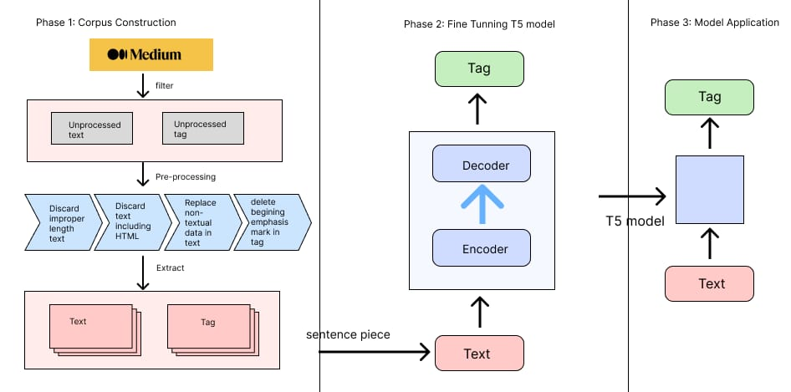

To design a solution architecture for a hashtag generator, consider a cloud-based approach. Utilize a serverless architecture using services like AWS Lambda or Google Cloud Functions to handle hashtag generation triggered by events, such as user inputs or content uploads. Store generated hashtags in a scalable database like Amazon DynamoDB or Google Cloud Firestore. Implement an API Gateway to expose hashtag generation functionality. Use natural language processing (NLP) techniques to enhance hashtag relevance.

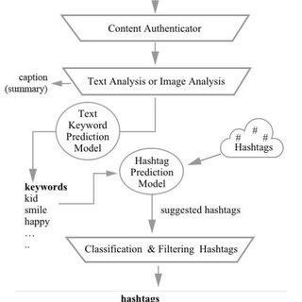

Certainly! Here's a simplified text representation of a solution architecture diagram for a hashtag generator:

**User Interface (UI):**

Input: User enters relevant keywords or content.

Output: Displays generated hashtags.

**Frontend:**

Captures user input and sends it to the backend.

**Backend:**

Receives generated hashtags from the backend and displays them to the user.

**Hashtag Generation Service:**

Takes user input from the frontend.

Utilizes algorithms/rules to generate relevant hashtags.

Sends generated hashtags back to the frontend.

**Data Storage:**

Stores historical hashtag data for analysis and improvement.

**APIs:**

External APIs (e.g., social media APIs) for fetching trending topics or related data to enhance hashtag relevance.

**Analytics:**

Gathers usage analytics for monitoring system performance and user engagement.

**Security:**

Implements security measures to protect user data and system integrity.

This architecture allows users to input content, have it processed by the backend hashtag generation service, and receive relevant hashtags through the frontend. The system may also leverage external data sources and analytics to enhance hashtag suggestions.

**PROJECT DESIGN PHASE -PART-2**

**DETERMINE THE REQUIREMENTS (CUSTOMER JOURNEY MAPS)**

* User becomes aware of the hashtag generation service through social media, search engines, or recommendations from peers.

* They learn about the features and benefits of the service through marketing materials and website content.

> CONTENT CREATION

> HASHTAG SUGGESTIONS

> USER-FRIENDLY INTERFACE

> REAL TIME PROCESSING

> CUSTOMER SUPPORT

> DATA SECURITY

> ANALYTICS DASHBOARD

> MARKETING AND ONBOARD MATERIALS

> SCALABILITY

> FEEDBACK MECHANISM

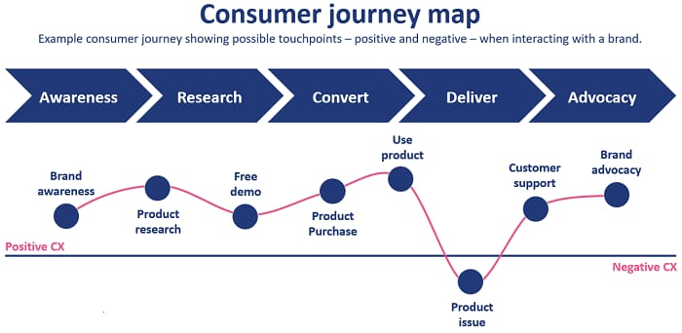

**REQUIREMENTS ANALYSIS**

**( FUNCTIONAL , OPERATIONAL ,TECHNICAL )/FLOW CHART:**

* Creating a flowchart for requirements analysis, including technical, operational, and functional aspects, is a complex task that often involves multiple steps.
* Here's a simplified textual representation of the flowchart.

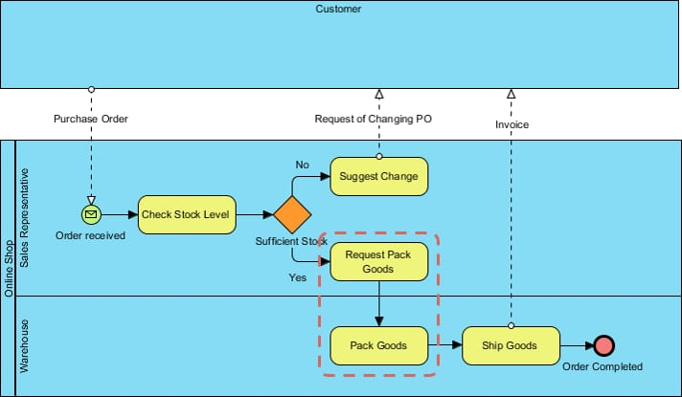**TECHNICAL ARCHITECTURE:**

* A hashtag generator typically involves natural language processing (NLP) and algorithmic approaches. You could use techniques like tokenization, stemming, and sentiment analysis to generate relevant hashtags based on the input text.
* Consider incorporating a database or predefined lists for common hashtags, and use algorithms to suggest related or trending tags.
* API integration with social media platforms may be necessary for real-time data on trending topics. Lastly, ensure scalability and efficiency in handling large volumes of data and requests.

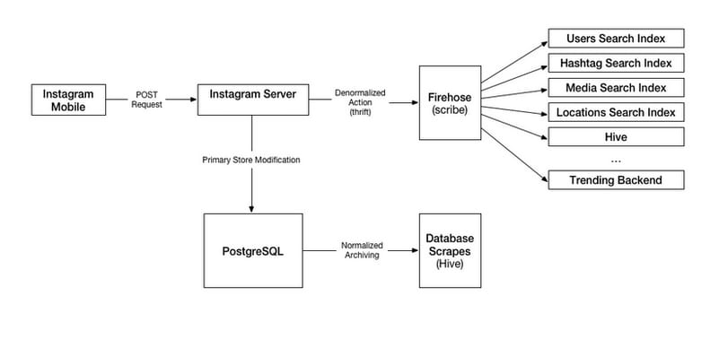

**PROJECT DEVELOPMENT PHASE**

**HASTAG GENERATION**

**No. Of Functional Features Included In The Solution**

| **Feature** | **Description** | **Importance** |
| --- | --- | --- |
| Content Analysis | Analyze user-provided content to extract keywords and understand context. | Essential for generating relevant hashtags. |
| Trend Integration | Monitor and incorporate trending hashtags related to current events and discussions. | Enhances visibility and topical relevance. |
| Platform Compatibility | Suggest hashtags suitable for specific social media platforms (e.g., Instagram, Twitter). | Ensures hashtags meet platform requirements. |
| Customization | Allow users to modify, add, or remove generated hashtags to align with their preferences. | Provides user control and flexibility. |
| Language Support | Support multiple languages and consider regional variations for global users. | Broadens user reach and relevance. |
| Privacy Protection | Ensure user-provided content is not stored or shared to protect user privacy. | Maintains user trust and data security. |
| Accessibility | Implement accessibility features for users with disabilities. | Ensures inclusivity and usability. |
| Real-Time Processing | Generate hashtags in real-time to provide immediate results to users. | Enhances user experience and efficiency. |
| Trend Analytics | Provide insights into hashtag performance and engagement metrics. | Helps users refine their hashtag strategies. |
| User Feedback | Collect user feedback and ratings to improve the quality and usability of the tool. | Allows for continuous refinement and enhancement. |
| Custom Hashtag Suggestions | Offer users unique and personalized hashtag suggestions based on their content. | Enhances user engagement and brand identity. |

This table outlines the key functional features that contribute to the success of a Hashtag Generation project, emphasizing their importance for the solution's effectiveness and user satisfaction. Depending on the scope of your project, you may include additional features or sub-features as needed.

**RESULT**

# *HASHTAG GENERATOR*

# *To identitfy the buzzing area*

*Our buzzing area is organic products.*

# 









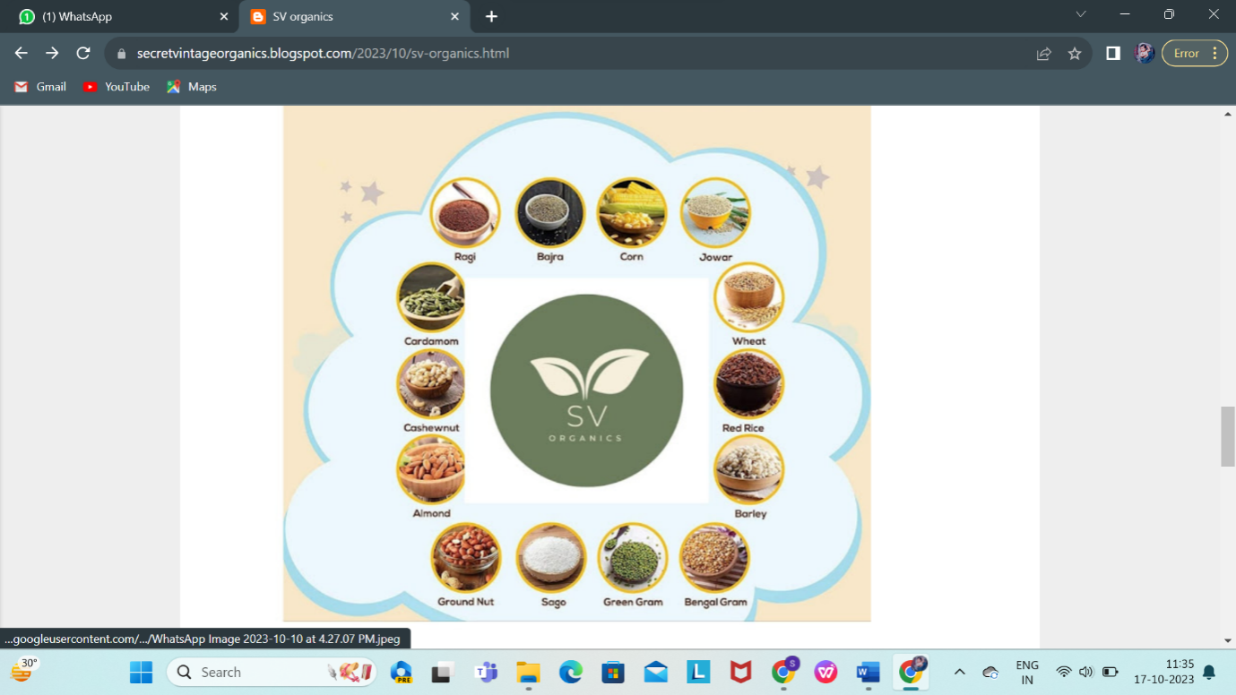



**CALCULATION OF PENETRATION POWER**

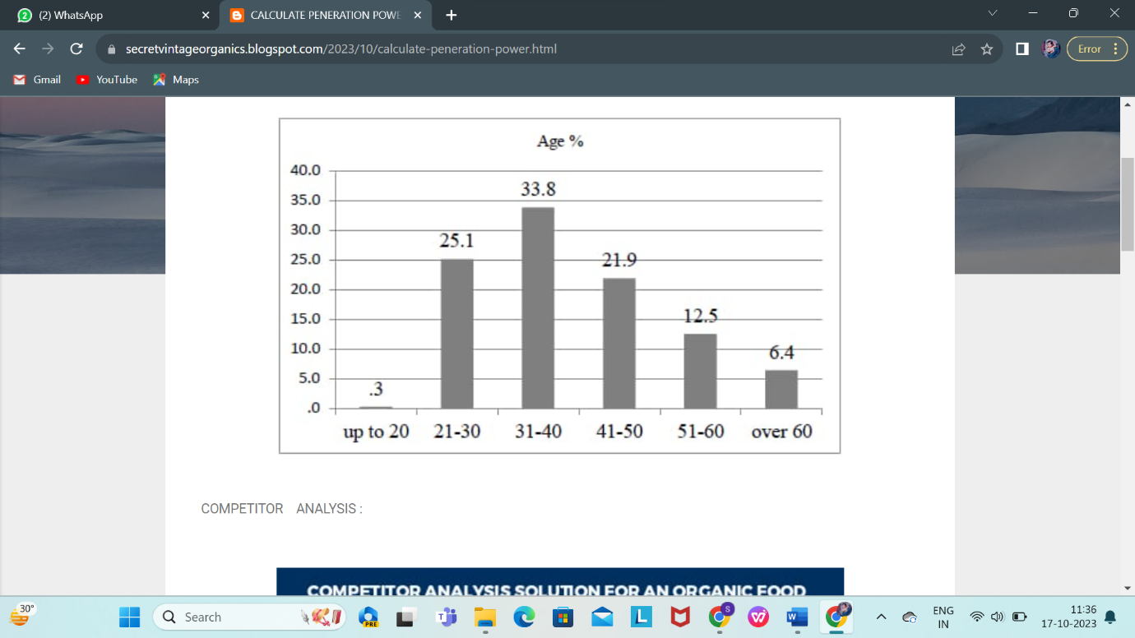

Audience size



**COMPETITOR ANALYSIS**

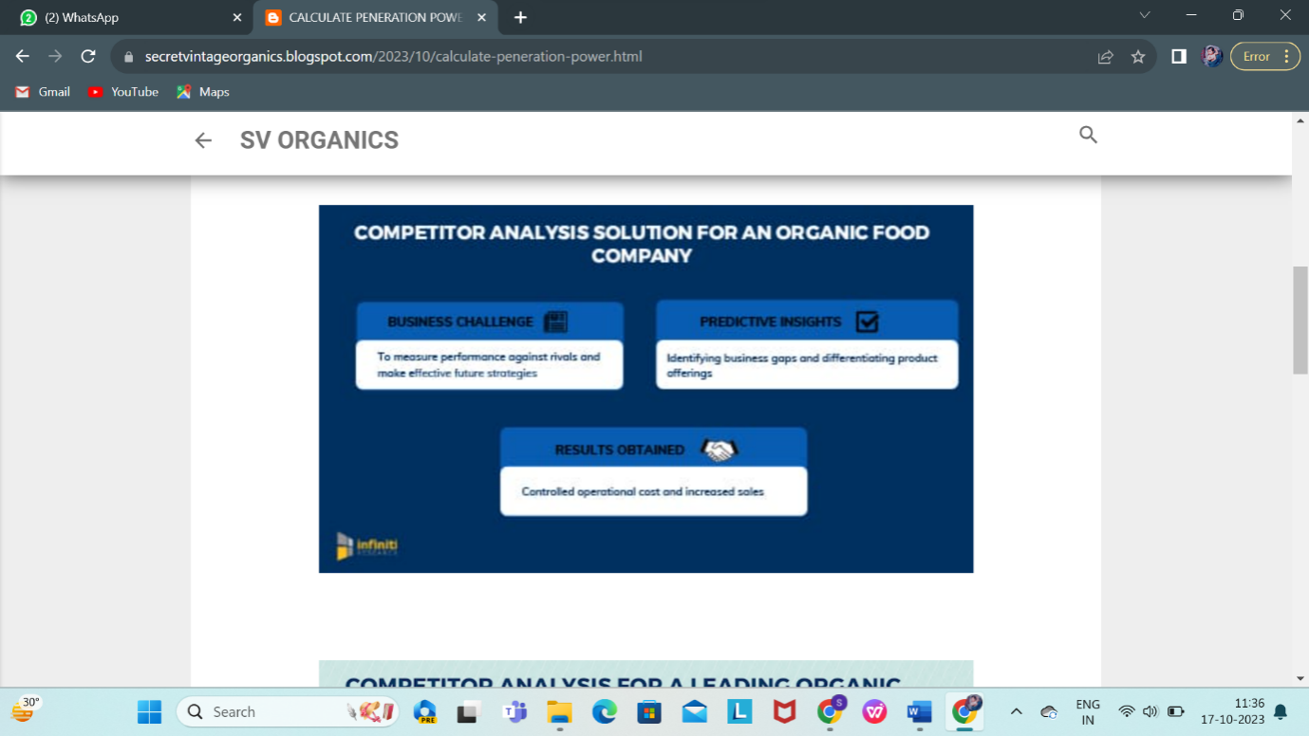

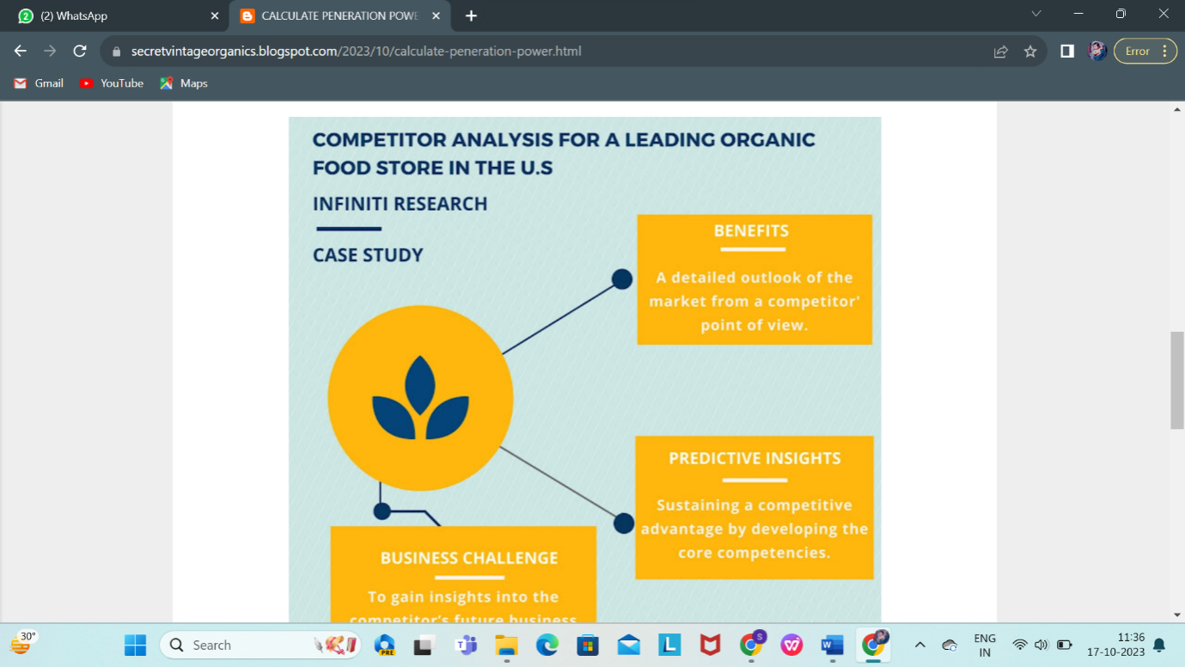

**INSTAGRAM HASTAG GENERATOR**

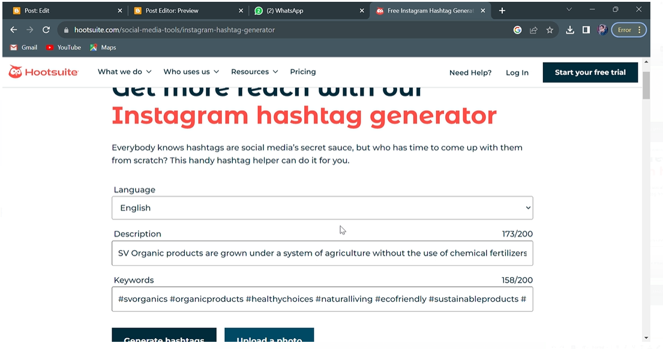

**OUR INSTAGRAM PAGE**

Istagram Post

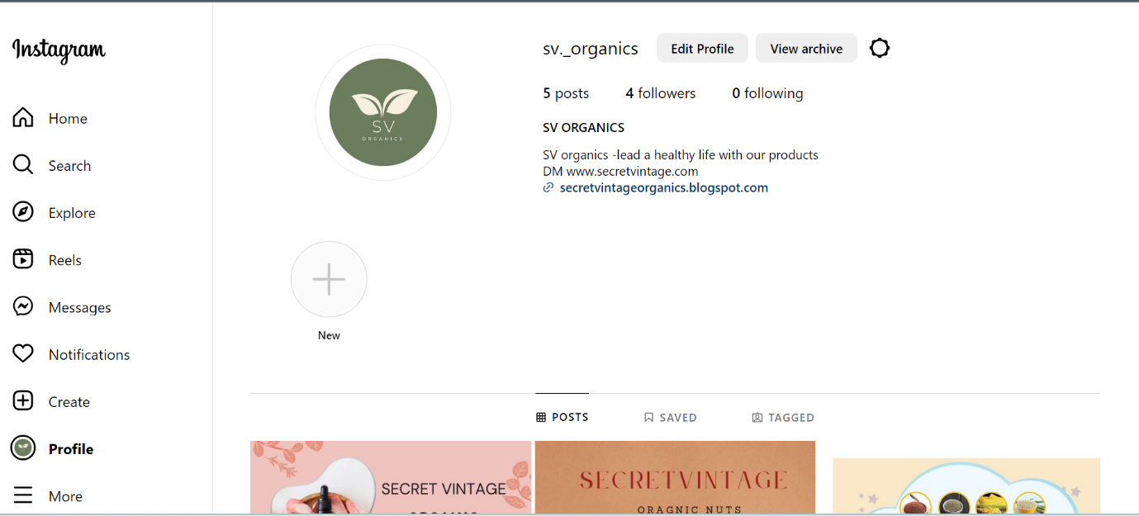



**INSTAGRAM POST FOR BRAND PROMOTION**





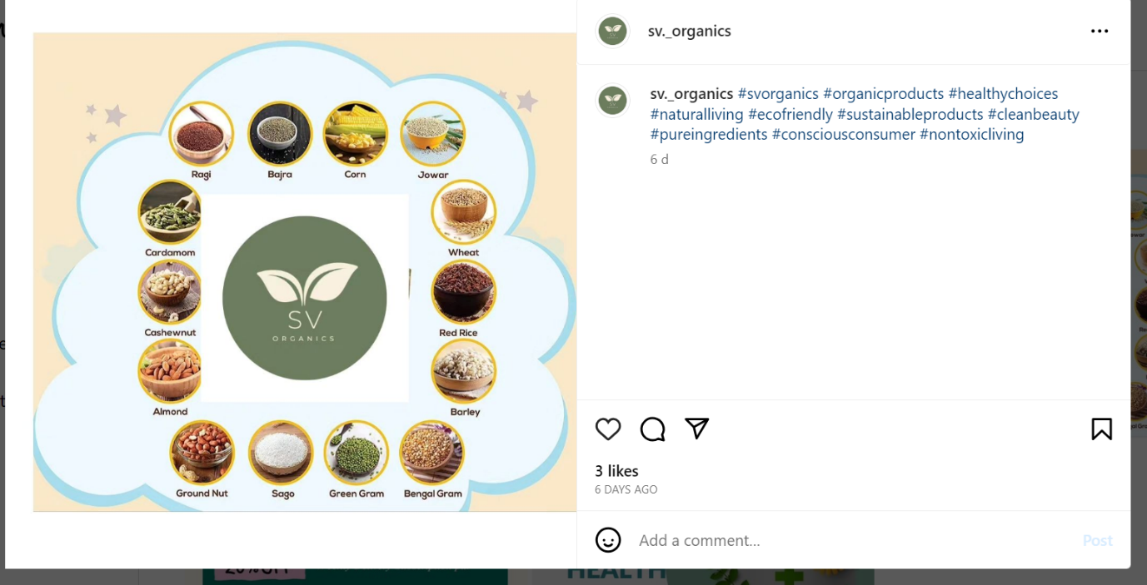





**BUILDING CURIOSITY AND TEASERS**

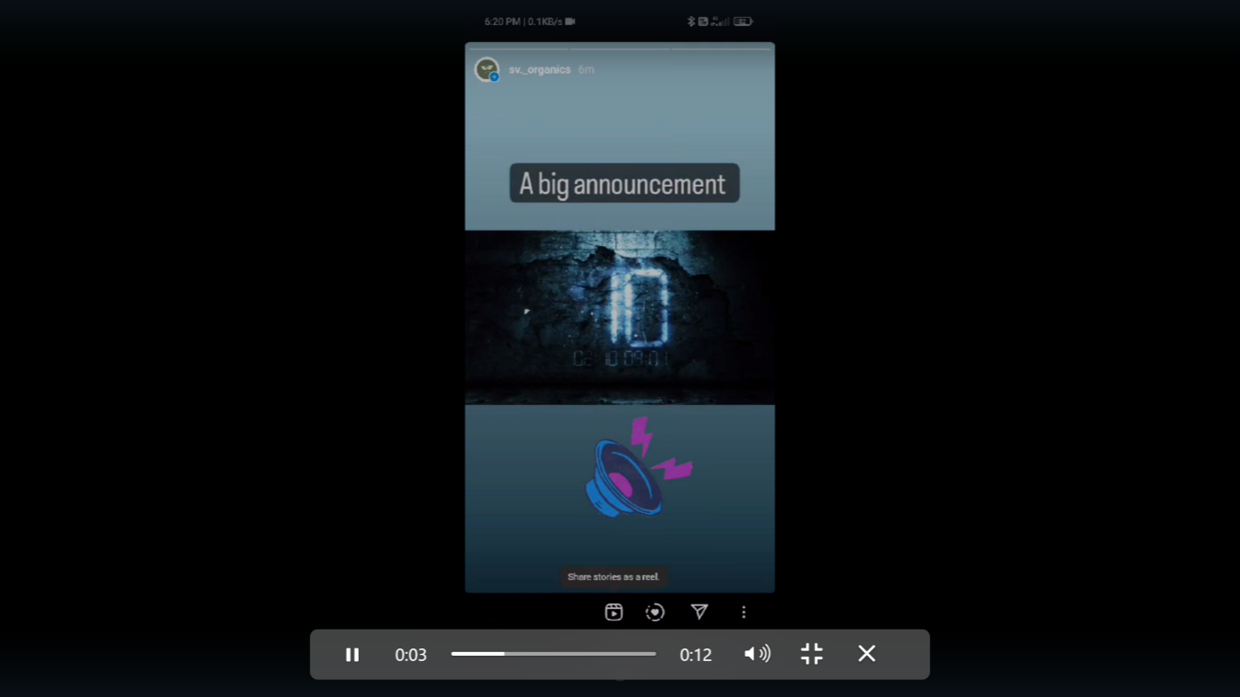



**ADVANTAGES & DISADVANTAGES**

**Advantages of Hashtag Generator:**

1. **Time and Effort Savings:** Hashtag Generators automate the process of hashtag creation, saving users significant time and effort that would otherwise be spent on manual research and brainstorming.
2. **Relevant Hashtags:** These tools use content analysis to suggest relevant hashtags, increasing the likelihood that the hashtags align with the content's topic and purpose.
3. **Enhanced Discoverability:** Well-chosen hashtags can improve content discoverability by making it easier for users to find and engage with posts, thereby increasing reach and visibility.
4. **Engagement Boost:** Suggested hashtags are designed to encourage user engagement, leading to more likes, comments, and shares, ultimately enhancing the impact of online content.
5. **Trend Integration:** Hashtag Generators can incorporate trending hashtags, helping users tap into popular discussions and current events, further enhancing the relevance of their content.
6. **Customization:** Users can customize the generated hashtags, adding their brand-specific or personal hashtags, giving them more control and the ability to tailor suggestions to their preferences.
7. **Platform Compatibility:** These tools provide hashtags suitable for specific social media platforms, ensuring that hashtags meet the platform's character limits and best practices.
8. **Language and Localization:** Hashtag Generators support multiple languages and consider regional variations, allowing users to connect with diverse audiences worldwide.
9. **Privacy Protection:** These tools prioritize user privacy by not storing or sharing user-provided content, ensuring data security and privacy protection.

**10. Accessibility:** Hashtag Generators are designed to be accessible to a broad range of users, including those with disabilities, ensuring inclusivity and usability.

**Disadvantages of Hashtag Generator:**

**1. Overreliance on Automation:** Users may become overly reliant on Hashtag Generators, potentially leading to less creativity and innovation in hashtag strategies.

**2. Algorithm Limitations:** The effectiveness of these tools depends on the accuracy and sophistication of their algorithms, and they may not always capture the full context or intent of the content.

**3. Relevance Challenges:** Some generated hashtags may not accurately represent the content's nuances or may not align perfectly with user preferences, requiring manual adjustments.

**4. Trending Topic Sensitivity:** While they incorporate trending hashtags, they may not always capture the full context of trends, leading to inappropriate hashtag suggestions in some cases.

**5. Limited Platform-Specific Insight:** While they provide platform-specific suggestions, they may not fully account for the nuances and best practices of each social media platform.

**6. User Learning Curve:** Some users may need time to become familiar with and trust the tool's suggestions, leading to a learning curve for new users.

**7. Continuous Updates Required:** To stay effective, Hashtag Generators must continuously update their algorithms to keep up with changing trends and social media platform policies.

**8. Data Privacy Concerns:** Some users may have concerns about data privacy, even if the tool does not store or share their content. Trust and transparency in data handling are essential.

**9. Cost for Premium Features:** Users may need to pay for premium features, such as unlimited hashtag generation, which can be a disadvantage for those looking for free solutions.

**10. Dependency Risk:** Relying too heavily on generated hashtags without understanding the principles of hashtag use and content strategy can pose a risk to users when the tool is unavailable or experiences issues.

**APPILICATIONS**

1. **Social Media Marketing:**

* + Social media marketers use hashtag generators to create relevant and engaging hashtags for their posts, helping increase the reach and visibility of their content.

**2. Content Creators:**

* + Bloggers, vloggers, and content creators use hashtag generators to make their content more discoverable on platforms like Instagram, Twitter, and YouTube.

**3. Business Promotion:**

* + Businesses and brands employ hashtag generators to promote their products or services, thereby increasing brand exposure and user engagement.

**4. Event Promotion:**

* + Event organizers use hashtag generators to create event-specific hashtags, making it easier for attendees to find and share content related to the event.

**5. Trend Tracking:**

* + Social media users use hashtag generators to identify trending topics and to participate in discussions or promotions related to those trends.

**6.Content Curation:**

* + Content curation platforms use hashtag generators to help users categorize and organize content based on relevant topics and themes.

**7. Digital Campaigns:**

* + Digital marketing campaigns, such as advertising or awareness campaigns, leverage hashtag generators to create campaign-specific hashtags and measure campaign performance.

**8. Influencer Marketing:**

* + Influencers use hashtag generators to optimize their posts and connect with a wider audience, which is crucial for their partnerships and collaborations with brands.

**9. Content Management Systems (CMS):**

* + CMS platforms can integrate hashtag generators to provide users with an automated way to improve the visibility of their content.

**10. Academic and Research:**

* + Researchers and academics use hashtag generators to enhance the discoverability of their publications and research findings on social media platforms.

**11. Nonprofit Organizations:**

* + Nonprofits utilize hashtag generators to raise awareness about their causes and engage with a larger community of supporters and donors.

**12. Content Recommendations:**

* + Content recommendation engines can incorporate hashtag generators to suggest relevant content based on user interests and preferences.

**13. Community Building:**

* + Online communities and forums use hashtag generators to help members categorize and discover content related to specific topics or discussions.

**14. User-Generated Content Campaigns:**

* + Brands and businesses running user-generated content campaigns encourage participants to use specific hashtags generated by the tool to share their content.

**15. Educational Tools:**

Educational platforms and institutions can use hashtag generators to teach students about the significance of effective social media communication and hashtag use

**FUTURE SCOPE**

The future scope of a hashtag generator, like many tools in the field of social media and online marketing, depends on several factors and trends in the digital landscape. Here are some potential areas of growth and development for hashtag generators:

**Advanced AI and Machine Learning Integration:** As artificial intelligence and machine learning technologies continue to evolve, hashtag generators can become more sophisticated in understanding and predicting trending topics, user preferences, and context. This can result in more accurate and relevant hashtag suggestions.

**Integration with Social Media Platforms:** Hashtag generators may become more tightly integrated with various social media platforms, offering real-time suggestions and analytics specific to those platforms. This can help users create more effective content tailored to their target audiences.

**Localized and Personalized Hashtags:** Future hashtag generators could consider a user's location, preferences, and online behavior to provide more personalized and localized hashtag suggestions. This can be particularly useful for businesses targeting specific geographic regions or niche markets.

**Content Curation:** Hashtag generators might evolve to not only suggest hashtags but also recommend content ideas or themes based on trending topics and user interests. This could help content creators stay relevant and engage their audience.

**Visual Recognition:** With the increasing importance of visual content on platforms like Instagram and Pinterest, hashtag generators may incorporate image recognition technology to suggest relevant hashtags based on the content of images or videos.

**Marketing and Analytics Integration:** Hashtag generators can provide more robust analytics and performance tracking features, helping users understand the impact of their chosen hashtags on their content's reach and engagement. They might also offer recommendations on optimizing hashtag usage for better results.

**Mobile Apps and Browser Extensions:** Mobile apps and browser extensions dedicated to hashtag generation could become more popular, offering quick and convenient tools for users to enhance their social media posts and content on the go.

**Data Privacy and Security:** As data privacy regulations become more stringent, hashtag generators may need to adapt to ensure they handle user data responsibly and securely. Compliance with privacy laws will be crucial for their continued success.

**Education and Training:** With the growing importance of social media in various industries, there could be a greater demand for educational resources and training on how to use hashtag generators effectively, including best practices for specific platforms.

**Collaboration and Integration with Content Creation Tools:** Hashtag generators may collaborate with content creation platforms, social media management tools, and other software to streamline the process of content creation, hashtag selection, and publishing.

It's important to note that the future of hashtag generators will depend on the evolving landscape of social media, technology advancements, and user preferences. As social media platforms continue to evolve and new ones emerge, hashtag generators will likely adapt to meet the changing needs of content creators and marketers.

## CONCLUSION

## 

In conclusion, the Hashtag Generator is a powerful and versatile tool that addresses the growing need for effective hashtag creation in the digital age. With the vast amount of content being shared on social media and online platforms, hashtags have become indispensable for improving content discoverability, enhancing user engagement, and amplifying the reach of messages. The Hashtag Generator automates this process, providing a range of benefits for individuals, businesses, content creators, and various organizations.

By leveraging advanced natural language processing and artificial intelligence algorithms, the Hashtag Generator analyzes content, extracts keywords, and understands context, ensuring that the suggested hashtags are relevant and align with the content's topic and intent. This relevance is essential for connecting with the target audience and increasing content visibility.

The tool also incorporates real-time trend awareness, seamlessly integrating trending hashtags into the suggestions. This feature keeps users at the forefront of popular discussions and current events, enhancing the impact of their content.

User customization is another valuable aspect of the Hashtag Generator. It allows users to add their own brand-specific or personal hashtags and modify the suggestions to align with their unique preferences and branding needs. This customization offers users more control over their content and messaging.

Privacy protection and accessibility are paramount considerations in the development of the Hashtag Generator. The tool respects user privacy by not storing or sharing user-provided content and is designed to be accessible to a wide range of users, including those with disabilities. These features ensure inclusivity and user trust.

The Hashtag Generator serves a multitude of applications, from social media marketing and content creation to business promotion, event organization, and influencer marketing. It is a valuable asset for users seeking to optimize their online presence, save time and effort, and enhance their engagement with their audience.

In summary, the Hashtag Generator represents a significant step forward in the digital landscape, simplifying and optimizing the process of hashtag creation. It empowers users to improve the visibility and engagement of their content while saving valuable time and ensuring that the hashtags generated are contextually relevant. The Hashtag Generator is a valuable tool for users and organizations looking to harness the full potential of hashtags in the digital era.